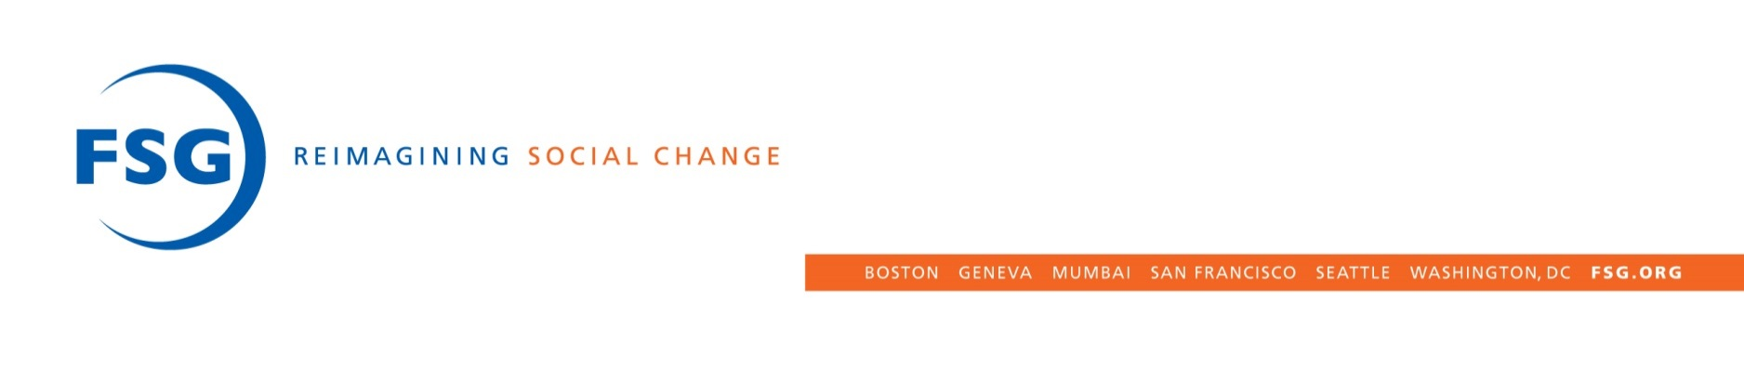**FSG Content 2016**   
Updated April 13, 2015

**Reports:**

* [Skandia Group Case Study: Creating Shared Value in Sweden's Financial Sector](http://fsg.org/skandia-group-case-study) March, FSG
* [Hardware Pioneers: Harnessing the Impact Potential of Technology Entrepreneurs](http://fsg.org/publications/hardware-pioneers) April, FSG

**Tools:**

* [Rethinking Rigor: Increasing Credibility and Use](http://fsg.org/tools-and-resources/rethinking-rigor) January, FSG
* [Is This a Better Place? The Art and Science of Place-Based Evaluation](http://fsg.org/tools-and-resources/better-place) April, FSG

**Articles:**

* [How Big Business Created the Politics of Anger](https://hbr.org/2016/03/how-big-business-created-the-politics-of-anger') March, *Harvard Business Review*

**FSG Blogs Sent Via Email \***

* [What Is the Difference Between Research and Evaluation?](http://fsg.org/blog/what-difference-between-research-and-evaluation) January, FSG
* [The Equity Imperative in Collective Impact](http://www.fsg.org/blog/equity-imperative-collective-impact) January, FSG
* [Fortune Ranks Top Companies Changing the World](http://fsg.org/blog/fortune-ranks-top-companies-changing-world) January, FSG
* [What Are Social Norms and Why Do They Matter for Girls?](http://www.fsg.org/blog/what-are-social-norms-and-why-do-they-matter-girls) January, FSG
* [Insurance, Social Impact, and Profit](http://fsg.org/blog/insurance-social-impact-and-profit) April, FSG

*\*Only includes blogs sent to FSG’s mailing list or FSG authored blogs sent to community mailing list*

**Total Blog Posts:**

* **FSG:**
* **CIF:** 
  + **Blog posts:**
  + **Community posts:**
* **SVI:**

*\*Update with number of posts at EOY*

**Videos**

**Webinars**

**Podcast**

**Events**

* [2016 Annual Davos Shared Value Initiative—FSG convening](http://fsg.org/events/2016-annual-davos-shared-value-initiative%E2%80%94fsg-convening) January, FSG/SVI
* [100,000 Opportunities Initiative Fair and Forum 2016](http://fsg.org/events/100000-opportunities-initiative-fair-and-forum-2016) February, 100k
* [From Self to Systems: Leadership for Collective Impact](http://fsg.org/events/self-systems-leadership-collective-impact) April, CIF
* [Champions for Change: Leading a Backbone Organization for Collective Impact 2016](http://fsg.org/events/champions-change-leading-backbone-organization-collective-impact-2016) April, CIF
* 2016 Shared Value Leadership Summit May, SVI
* [Collective Impact Learning Lab: Tools and Techniques for Achieving Results](http://fsg.org/events/collective-impact-learning-lab-tools-and-techniques-achieving-results) May, CIF
* [2016 Collective Impact Convening](http://fsg.org/events/2016-collective-impact-convening) June, CIF